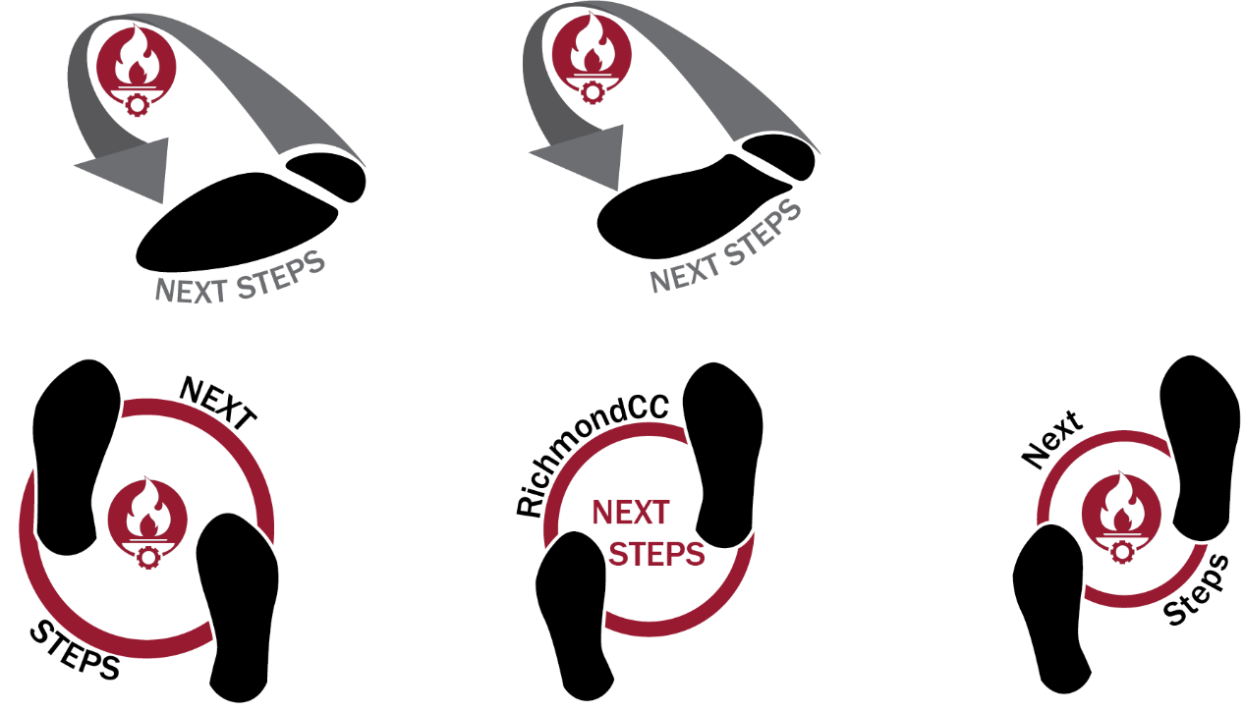


APPLICATION

Date of Application: ____________________

Name: ________________________________________________________________________

Address: ______________________________________________________________________

City: ____________________________________ State: _____________ Zip: ______________

Phone: _______________________________________________________________________

Email: ________________________________________________________________________

Date of Birth: ____________________________

Are you your own legal guardian? YES NO
If No, please list the name and contact for your legal guardian:

Name: _______________________________________________________________________

Phone: _______________________________________________________________________

Email: ________________________________________________________________________

Do you have transportation to our campus?

- I will apply for Area of Richmond Transit (ART).
- Someone else will drive me.
- I will drive myself.
- Other ______________________________________________________________

What, if any, employment or volunteer experience do you have? ________________________

______________________________________________________________________________

______________________________________________________________________________

I understand and agree to the Enrollment Criteria for the Next Steps program below.
Enrollment Criteria | YES |  | NO
- CASAS Reading GOALS score 194 or higher or TABE score of 320 or higher.
- Agree to Vocational Rehabilitation referral.
- Understanding that goal of program is to prepare students
for entry into the workforce.
- Ability to attend to personal needs (toileting, preparing
lunch, self-administer medication or take medication or take
care of other medical needs) OR acquire services of personal
care assistant to assist with needs.
- Ability to communicate effectively with other students,
faculty, and staff.
- Demonstrate awareness of and observe appropriate social
boundaries.
- Ability to refrain from distracting or disruptive behaviors
which inhibit the ability to learn of self and others in the
classroom environment.
- Ability to follow directions.
- Understanding of strict attendance policy.
- Willingness to enroll in Career Pathway program and/or
seek and obtain employment.
- Student and caregiver/guardian will agree to RichmondCC
Policies and Procedures and Student Rights and Responsibilities.

Student Name (Print) _________________________________________________________

Student Signature____________________________________________Date_____________

Guardian/Parent Signature _____________________________________Date_____________
1/22/2024

